

**endTB Clinical Trials**

**Frequently Asked Questions (FAQ)**

**Pharmacy Manual**

**Version: 1.0 Date: 01 June 2020**

Contenu

**1.** **Instructions to prepare yearly forecast** 3

**2.** **How to download Certificate of Analysis from MSF logistique website.** 7

**3.** **How to post a complaint to MSF logistique online.** 11

**4.** **How to check data logger battery residual life.** 15

# **Instructions to prepare yearly forecast**

**Note:** These instructions apply to endTBO2 and Q-study (forecast for the two trials must be handled separately)

**Step 1 – Adapt control arm regimens to include last updated WHO recommendations**

<https://www.who.int/tb/publications/2019/consolidated-guidelines-drug-resistant-TB-treatment/en/>

<https://www.who.int/tb/publications/2019/rapid_communications_MDR/en/>

Please see also assumptions shared by the central team and adapted to the site by site PI

 ***Step 1 should be performed after discussion with clinicians, Study Co and PI.***

1. If you are using a specific single drug file for the control arm please adjust percentage for each drug (see example below).

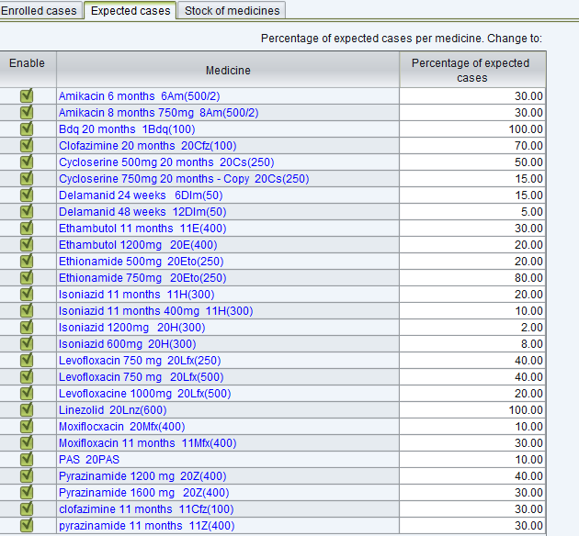

1. If you use the multidrugs regimen file for the control arm (together with multidrug regimen of the experimental arm)

* Change or create the most likely regimens for the control arm taking into consideration the new WHO GL, Co-PI and site PI recommendations.
* Modify the control arm regimen for patient who are already under treatment (after discussion with clinicians/PI as we should ensure that the patient will remain in the study despite the changes)

(see example below):

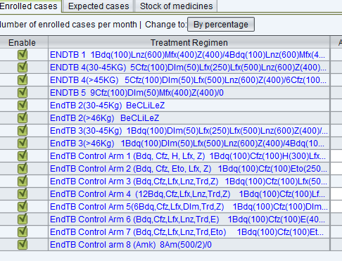

**Step 2 – Check expected cases**

Check with Study Co (and/or Central Clinical Trial Pharmacist) that the expected cases per month are according to the last update monthly randomization projection and revise distribution of expected cases in multidrug regimen file and in single regimen file (if still maintained).

**Step 3 – Update stock on hand**

Update the stock on hand based on the last inventory report.

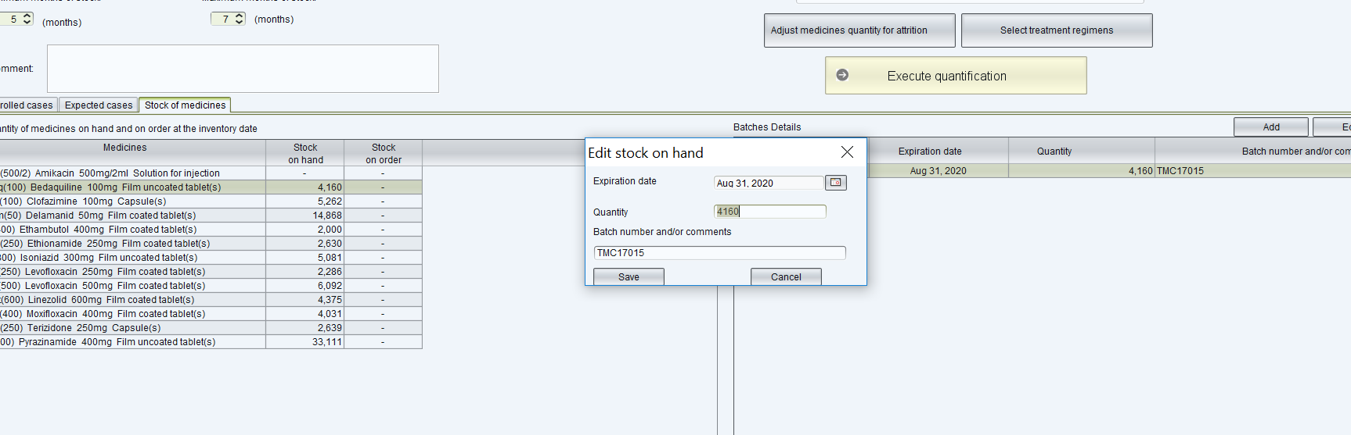

**Step 4 – Change parameters**

Please change parameters as indicated below (as an exemple). Parameters to be indicated by the Clinical Trial Pharmacist.

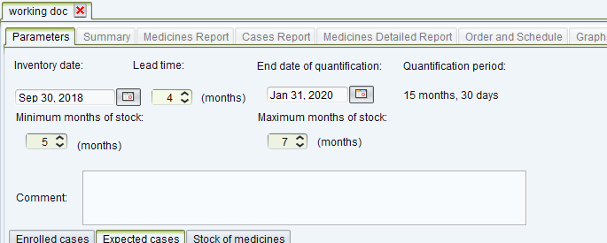

**Step 5 – Execute quantification**

Click on Execute Quantification

Click on Order and Schedule

Click on Schedule

Select Bi-annualy (Schedule of orders)

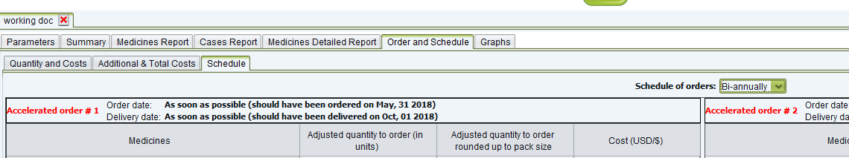

Consider only the order covering the forecasting period.

In this example you will have to compile the quantities for 2019 only meaning order #2 and order #3 only.

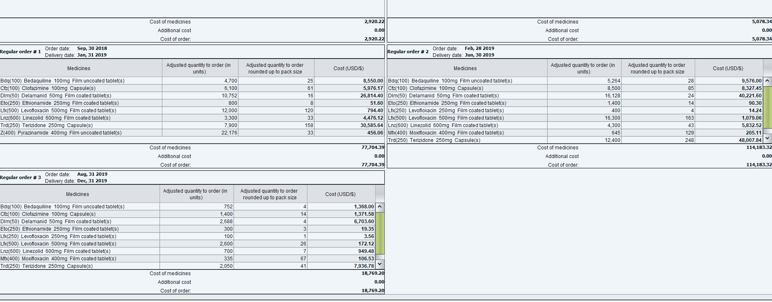

**Step 6 – Consolidate quantities**

To consolidate the quantities, use the QuanTB function “export to Excel”.

If you use two files one for single drug control arm and one for multidrugs regimen experimental arms, do not forget to consolidate the quantities from the two files.

Once you have extract data in Excel and consolidate all the data, copy the total in the attached excel template.



**Note**

Quantification is also required for two ancillary medicines:

EPOETIN ALFA, 10 000 IU/ml, 1 ml, graduated syringe

PYRIDOXINE hydrochloride (vitamin B6), 50 mg, tab.

(PYRIDOXINE hydrochloride (vitamin B6), 100 mg, tab.)

For Pyridoxine you can also use QuanTB as explained in the following communication



# **How to download Certificate of Analysis from MSF logistique website.**

<https://www.msflogistique.org/>

1. Click Extranet upper corner right

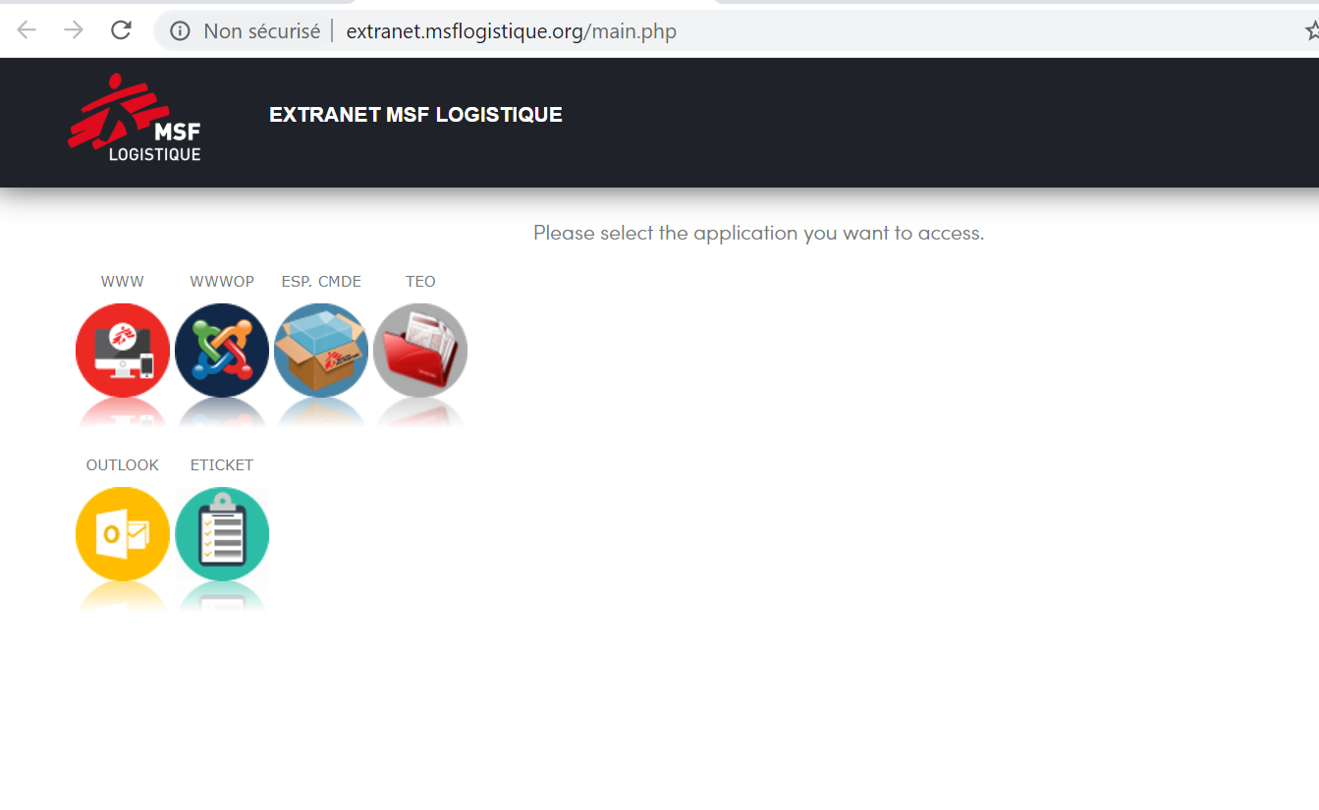

1. Click WWWOP

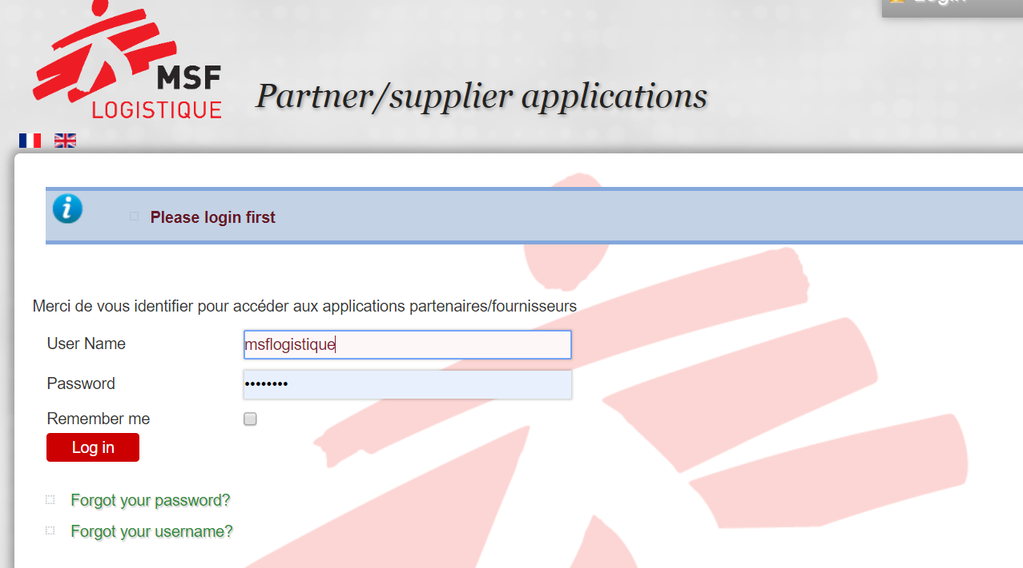

1. Click on the UK flag

Enter

ID : msflogistique

Password : bordeaux

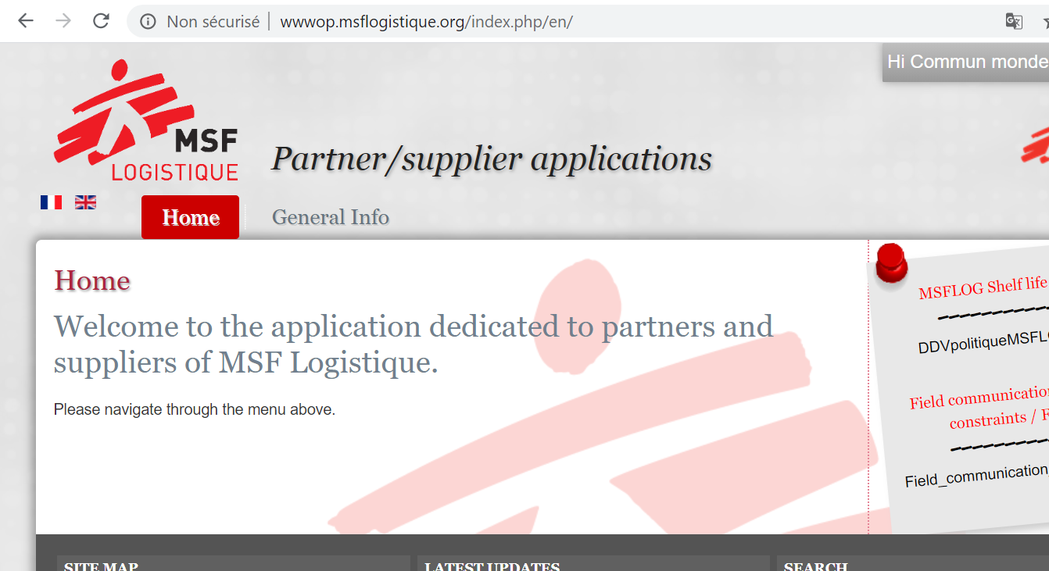

1. Click general info

Select :

Order tracking

Edition of Analysis Certificate (CoA)

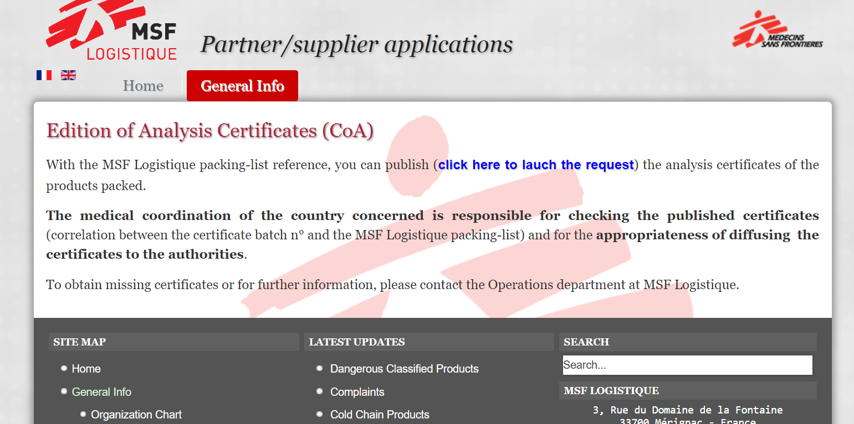

1. Click here to launch the request (see arrow)

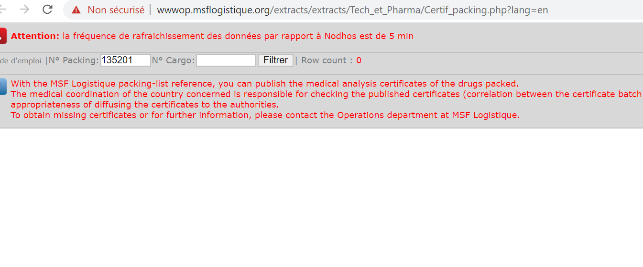

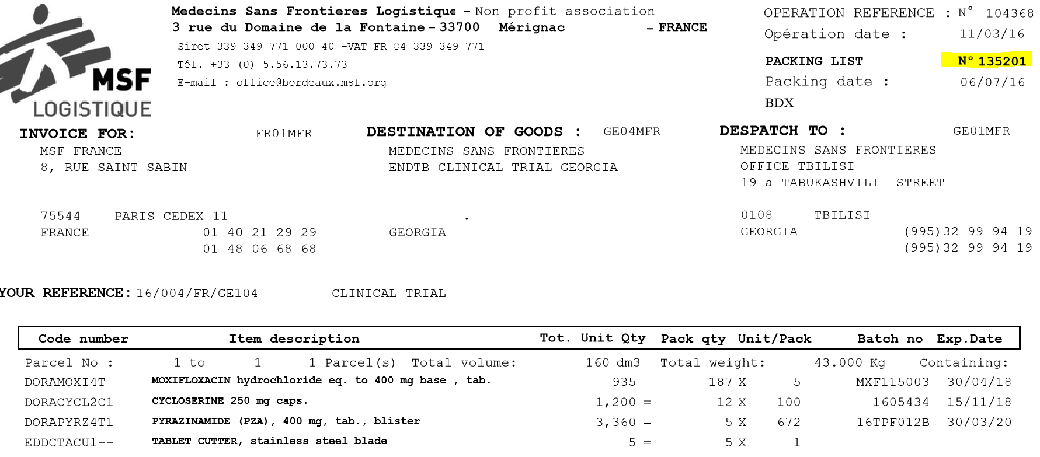

1. Enter packing list number (ex 135201)

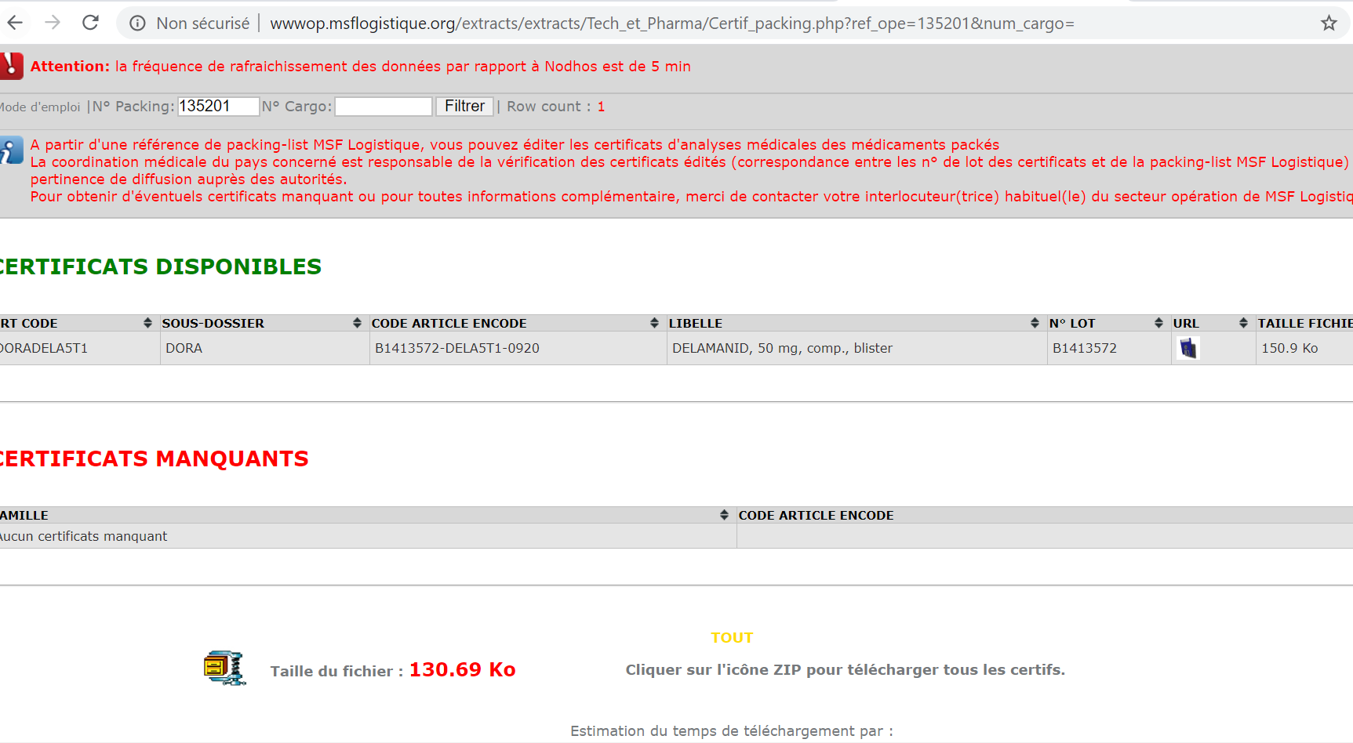

1. “Filtrer” and download CoA

# **How to post a complaint to MSF logistique online.**

<https://www.msflogistique.org/>

1. Click Extranet upper corner right



1. Click WWWOP



1. Click on the UK flag

Enter

ID : msflogistique

Password : bordeaux



1. Click general info

Select :

Supply Info

Complaints

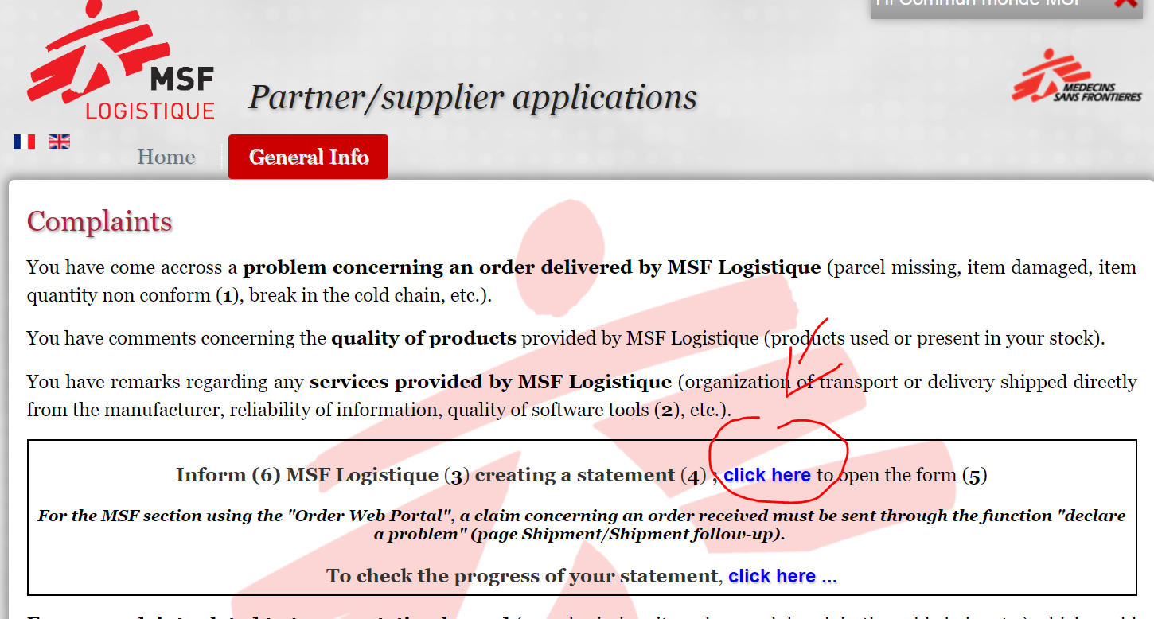

1. Click here (see arrow)

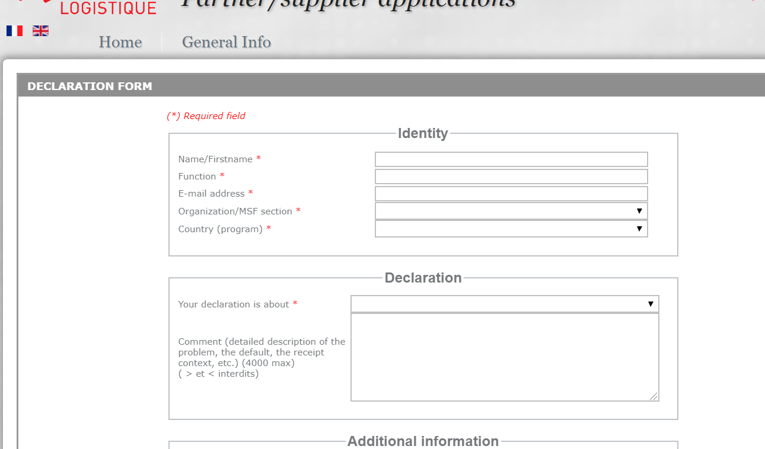

1. Complete the form and do not forget to add the logtag records.

# **How to check data logger battery residual life.**

On the data logger itself the LEDs will give some indication on the battery.

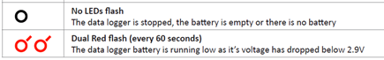

It is also indicated by the computer when you connect the USB datalogger

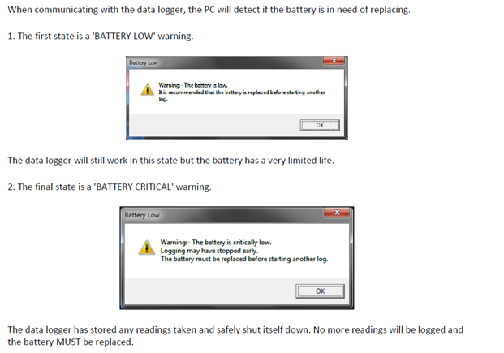

[EasyLog 21CFR Operational Guide](https://www.lascarelectronics.com/media/5981/easylog-21cfr-operation-guide.pdf)