**Setting and Use of the data logger**

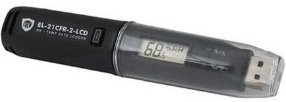Data logger (PCOLMONIHL2) for each drugs storage location (room and fridge) **Important note :** Once the battery (that should last for 2 years) is flat the entire device should be changed.

* + For room: T° (15°≤T°≤25°C) + RH (RH≤60%), 1 record per hour. Put the device with the drugs
  + For fridge: T° only (2°C ≤ T ≤ 8°C), 1 record per hour. Put the device in the basket where are the drug (EPO). Set a “start delay” at 15 minutes.

A quick start guide will be provided with each data logger. Follow the instructions to download the software <http://www.lascarelectronics.com/software/easylog-software/easylog-21cfr-usb>

Once the software is installed, plug the data logger on your computer and open the software. You have now to set up and start the data logger:

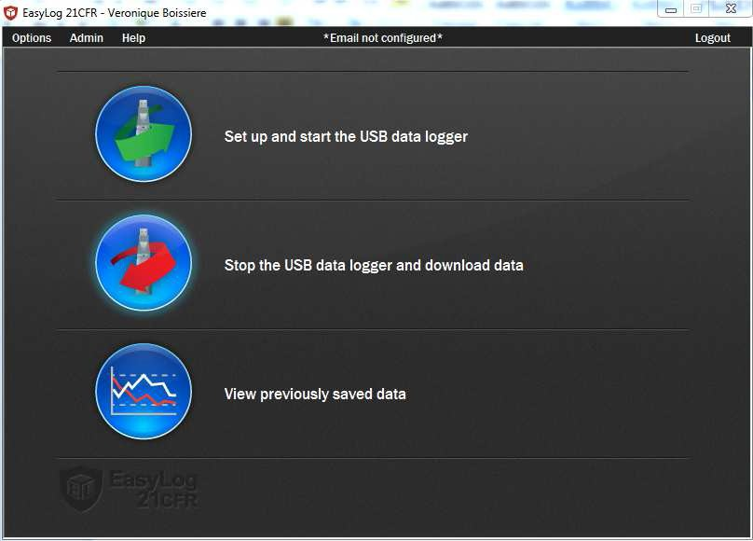

* Logger name: put the name of the location where the logger will be used
* Temperature: °C
* Frequency: 1 hour

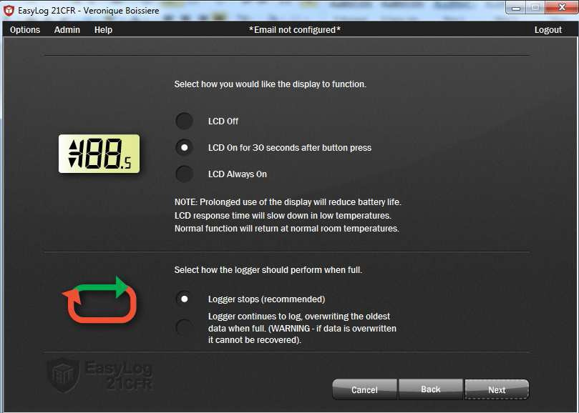

For ROOM: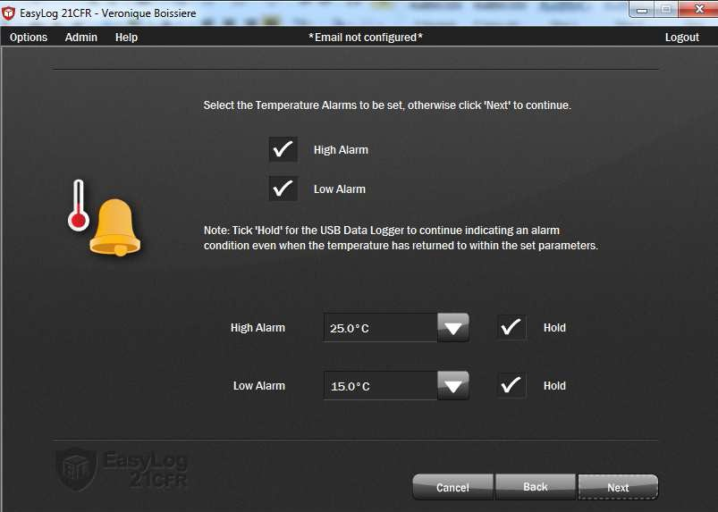

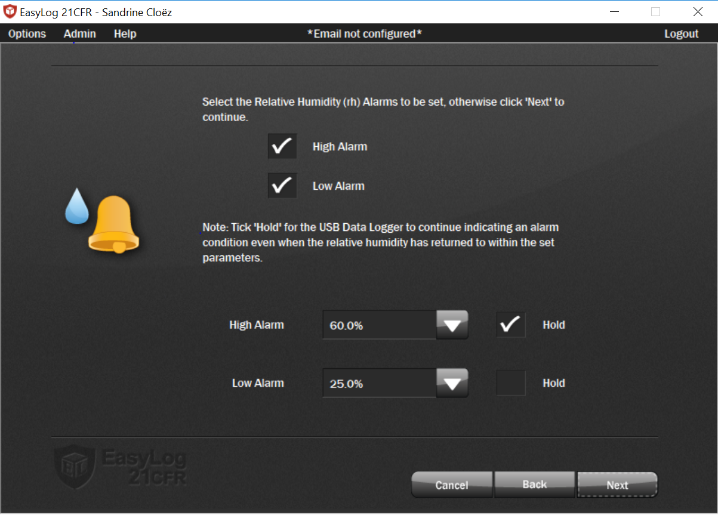

For FRIDGE:

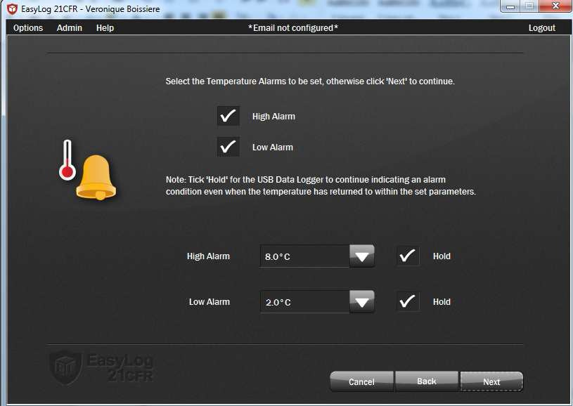

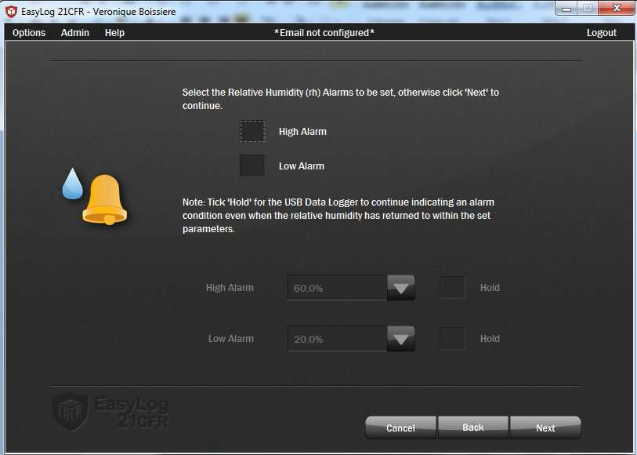

(no alarm set on humidity for fridge)

For both room and fridge:

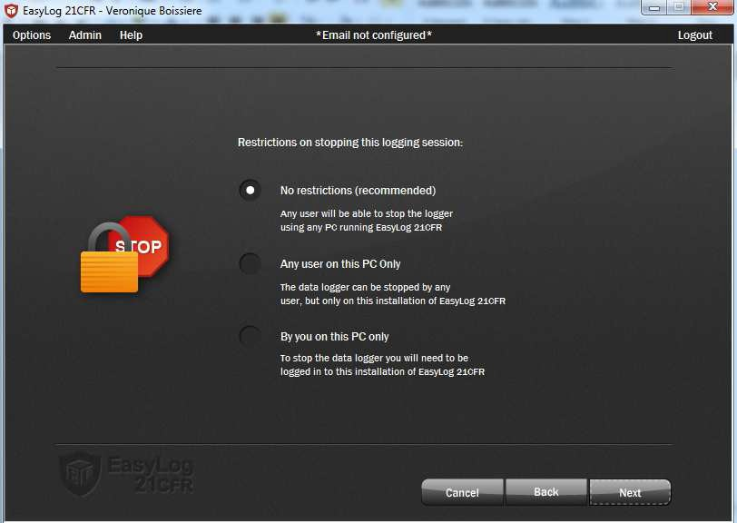

For room:

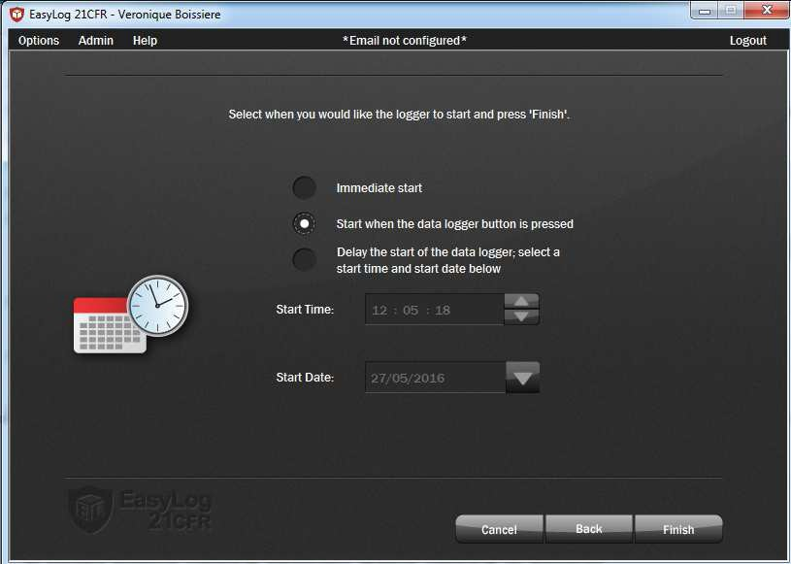

And do not forget to press the button once the logger is in its location

For fridge 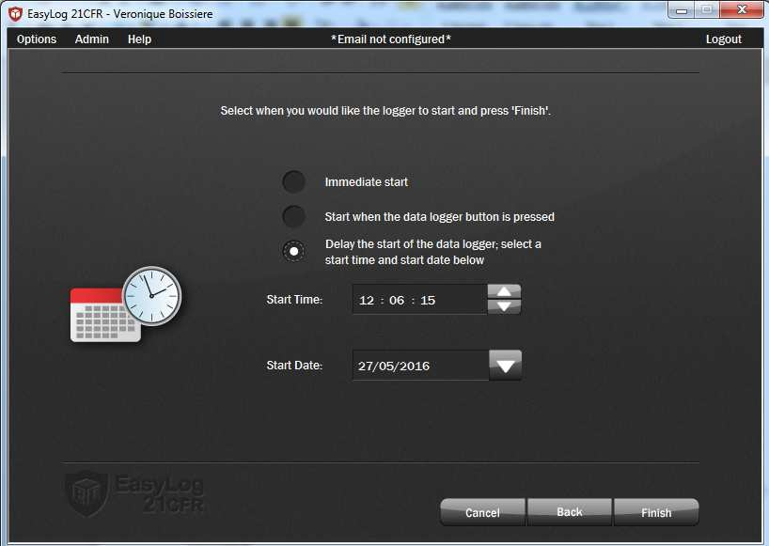

Start date=today

Start time= in 30 minutes from now

It is important to delay the start for the fridge logger. If you do not, the first record will be out of range (the first record will occur when the logger is still in the room then the temperature will be >8°C then the logger will be in alarm)

To stop, read and file the records you click here:

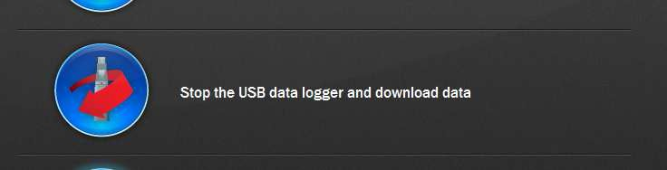

And follow the instructions.

To see previous data recorded, you click here:

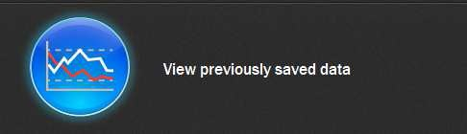

Go to the folder where you saved the data and open the file you want to read.

**Data Logger calibration and battery life**

**Device :** EasyLog EL-21CFR-2-LCD Data Logger from Lascar Electronics

According to manufacturer specifications, deviations of measurement of the data logger on the long term are negligible: temperature <0.02°C/year and humidity <0.25% RH/year. Therefore the data logger can be used during the entire battery life (2 years) without recalibration.

The sites should ensure they have spare datalogger to replace devices for which the battery has run out.

<https://www.lascarelectronics.com/easylog-data-logger-el-21cfr-2-lcd/> (accessed on 31 Jan 2018):

