 | Drug storage assessment form  Country: |__|__|-|__|

Central Medical Store (tick) ☐ or Dispensary pharmacy (tick) ☐ or
Institution pharmacy (tick) ☐
(Please fill in one form per location)
Assessment done by study coordinator or site pharmacist:
Name: _____________________________ Function: ____________________________
Date of assessment: |__|__|-|__|__|__|-|__|__|__|__| (dd-Mmm-yyy)
Signature: ___________________________
ROOM
- Access restricted (authorized staff must be listed on the study delegation log) | yes ☐ | no ☐
- Dedicated space for IPs and ancillary drugs | yes ☐ | no ☐
- Equipment in place (A/C, heater, curtains) to insure a temperature 15°C ≤ T° ≤ 25°C, a relative humidity ≤ 60% and no direct sunlight | yes ☐ | no ☐
- LogTag readers (PCOLMONITL0S) on site or on order from MSF-Logistique 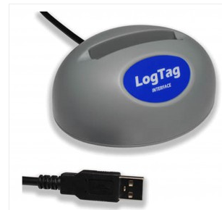 | yes ☐ | no ☐
- Data loggers ((PCOLMONIHL2) on order from MSF-Logistique for each drugs storage location 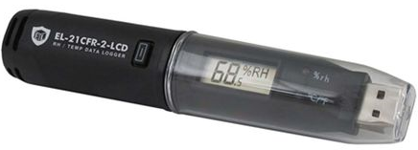 | yes ☐ | no ☐
- Temperature and relative humidity log in place in each drugs storage location | yes ☐ | no ☐
- Destruction area: there is a dedicated area (and separated from storage) for the drugs to be destroyed | yes ☐ | no ☐

COLD CHAIN
- Vestfrost fridge or equivalent in place or on order from MSF-Logistique | yes ☐ | no ☐
- Freezer (for Ice pack) available (for central storage only), please precise the exact location: ________________________ | yes ☐ | no ☐
- Vaccine carrier (PCOLBOXCG6-) available on site or on order from MSF-Logistique | yes ☐ | no ☐
- Temperature and relative humidity log in place on the fridge | yes ☐ | no ☐

Transportation between the Central Medical Store and the institution pharmacy (ies) or between two sites

- Transportation of drugs between the Central Medical Store and the institution pharmacy(ies) (for distribution) or between two CMS of different sites is in place to ensure 15°C ≤ T° ≤ 25°C | yes ☐ | no ☐

Once completed, please scan and send this document to the Central Trial Pharmacist or designee.
A written answer will be sent back until the final feedback is “storage conform”.

Storage conformity validation (Clinical Trial Pharmacist or designee):

Name: _____________________________ Function: ____________________________

Date: |__|__|-|__|__|__|-|__|__|__|__| (dd-Mmm-yyy)

Signature: __________________________

