

SERIOUS ADVERSE EVENT (SAE) REPORT FORM

Guidelines for completion

Author | MSF PV unit
Date | 15-Dec-2015
Version | 2.0

Table of content
Table of content 2
List of abbreviations 3
1. Introduction 4
2 General instructions 5
3 Detailed instructions 6
3.1. Administrative information 6
3.2. Patient information 6
3.3. Serious adverse event(s) information 6
3.4. Suspected drugs 8
3.5. Causality assessment 9
3.6. Event description 9
3.7. Relevant laboratory tests 10
3.8. Concomitant medications 10
3.9. Medical history 10
3.10. Reporter information 10
3.11. Case status and annexes 11
4 Special situation – Parent/Child Foetus reports 11
5 References 11

List of abbreviations
AE | Adverse event
CT | Clinical trial
DDI | Drug-drug interaction
ICH | International Conference on Harmonisation of Technical Requirements for Registration of Pharmaceuticals for Human Use
INN | International Non-proprietary Name
PV | Pharmacovigilance
SAE | Serious adverse event
TB | Tuberculosis
WHO | World Health Organization

Introduction
A Serious Adverse Event (SAE) is any untoward occurrence in a patient given a pharmaceutical product and that at any dose:
- Results in death,
- Is immediately life-threatening, meaning the patient was at risk of death at the time of the event. It does not apply to an event which hypothetically might have caused death if it were more severe.
- Requires inpatient hospitalisation or prolongation of hospitalisation. This seriousness criterion does not apply to out-patient hospital visits.
- Results in persistent or significant disability/incapacity meaning a substantial disruption of patient’s ability to carry out normal life activities.
- Is a congenital anomaly/birth defect in a child whose parent was exposed to a medicinal product prior to conception or during pregnancy.
- Is considered otherwise medically significant: other situation such as important medical events that may not immediately be life threatening or result in death or hospitalisation, but jeopardise the subject or require intervention to prevent one of the outcomes listed in the definition above, should also be considered serious (e.g. treatment in an emergency room for allergic bronchospasm). Medical judgment should always prevail in the assessment of medically significant events.
Any SAE as defined above occurring in the frame of a CT or a program sponsored by MSF is reportable within 24 hours of awareness to MSF Pharmacovigilance (PV) Unit using an SAE Report Form:
Email: PVunit.GVA@geneva.msf.org
Additional information on already transmitted SAEs, called follow-up information, should be reported similarly within 24 hours of awareness of the new information.
Unless described otherwise in the CT protocol or the program’s PV guideline, overdoses are additionally reportable in an expedited manner (within 24 hours of awareness) to MSF PV Unit. An overdose is defined as the administration of a quantity of a medicinal product given per administration or cumulatively which is above the maximum recommended dose according to the authorised product information or other in-use references (e.g. WHO guidelines). Clinical judgement should always be applied when evaluating whether an overdose was administered or not. The SAE Report Form should be used for overdose reporting even in the situations where the reported overdose did not lead to serious medical consequences.
Pregnancies are collected and reported using a dedicated form (Pregnancy Report Form) described in a separated guideline (Pregnancy Report Form completion guidelines).
In some CTs or programs, other types of events may require notification (e.g. AEs of special interest, medication errors). When no dedicated form is planned per CT protocol or program’s PV guidelines, the SAE report form can be used for this purpose.

General instructions
The SAE Report Form is designed to allow for a proper case assessment and appropriate reporting in accordance with the applicable international standards (ICH E2B). The available fields must be completed as much as possible with the relevant information available at the time of reporting.
The minimal information to be reported includes:
- Name or any identifier of a reporter (e.g. a function such as ‘nurse’ is acceptable),
- Any identifier of the patient (e.g. patient number, initials, date of birth),
- At least one suspected drug (study drug in a CT/ delivered drug in a program),
- At least one serious adverse event (or overdose or any other safety information to be collected as per CT protocol/program’s PV guideline).
The following general points aim at helping the completion of the SAE Report Form:
- Dates should be provided in the “Day/Month/Year” format: dd/Mmm/yyyy (e.g. 06/Apr/2015). If the exact date is not known, a partial date can be provided and the full date completed later upon follow-up (e.g. UNK/Apr/2015).
- In case you need to add more information than a field allows you to enter, please reprint the page, add manually the mention ‘Supplemental page’, and capture the additional information.
- Upon receipt of follow-up information on an SAE already notified (e.g. the patient has now fully recovered), the initial information does not need to be fully repeated on the SAE Report Form, only the new information with identifiers allowing to retrieve the initial information (site number, patient’s identifiers, case number, diagnosis, etc.).
- In case corrections are needed, the correct vs. the incorrect information should be clearly identifiable and the correction should include the initials of the person who performed the modification and the date of such modification.
- All information about the patient must be anonymized in all documents before transmission to the MSF PV Unit.
As a general medical guideline, the following points should be considered:
- When several events are signs and symptoms grouped under a single diagnosis, the diagnosis should preferentially be reported. Relevant signs and symptoms can be described in the free-text field allowing for event’s description (see section 3.6).
- In case several reportable events occurred at the same time in a same patient, it is upon the Investigator’s/physician’s judgment to report these on a same SAE Report Form or on separated SAE Report Forms.
  - Example 1, a patient is hospitalized with concomitant fever and nausea of unknown origin -> it is advised to use of a single SAE Report Form mentioning fever and nausea.
  - Example 2, a patient experienced life-threatening anaphylactic shock during drug infusion, his lab data revealed a grade 4 thrombocytopenia -> it is advised to report anaphylactic shock on an SAE Report Form and to report grade 4 thrombocytopenia on a separated SAE Report Form.
- Anonymized copies of relevant hospital records (e.g. discharge summary), additional lab results, list of concomitant drugs or therapies, should be provided as attachments. In addition, for fatal cases, autopsy report if available should be provided (refer also to section 3.11).
The MSF PV Unit is available for questions and further guidance on the SAE Report Form completion.

Detailed instructions

Administrative information
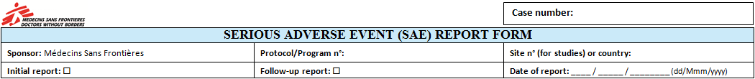
For CTs, protocol and site numbers should be informed. For other programs, the program number or name, as well as the country of occurrence of the event should be entered.
When transmitting information on an SAE for the first time, the box ‘initial report’ should be ticked, when reporting supplementary information on an SAE previously transmitted, ‘follow-up report’ should be selected.
‘Date of report’ field title is self-explanatory.
The field ‘Case number’ is available to capture the number of the case attributed by MSF PV unit; at time of initial reporting this field should be left blank.

Patient information
For CTs and programs where patients are allocated an alpha-numeric identifier, the appropriate field (‘Patient n°’) should be populated with this information. All information about the patient must be anonymized. Other fields’ titles are self-explanatory.

Serious adverse event(s) information
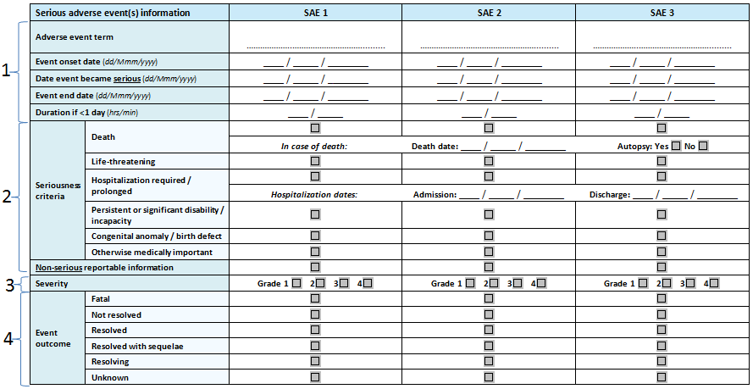
- Up to 3 SAEs can be entered, if more SAEs have to be reported, the page can be re-printed with the mention ‘Supplemental page’ and incremented numbering ‘SAE 4, 5, 6’ added manually. If all signs and symptoms experienced by a patient can be grouped under a single diagnosis, diagnosis should be reported as ‘Adverse event term’ and signs/symptoms only reported under ‘Event description’ (section 3.6). In the situations, where diagnosis is not feasible at time of reporting, signs and symptoms should be listed as ‘Adverse event term’.
  - The numbering (SAE 1, SAE 2, SAE 3) allows for causality assessment in section 3.5.
  - Adverse event term for cases of overdose should be ‘Overdose of [Drug name]’.
  - Date of onset, date the event became serious and date of resolution of the event should be documented.
    - If the event is ongoing at time of reporting, the event end date should be left blank.
    - Onset date and date the event became serious can be similar or different, e.g. fever grade 2 starting on 03-Apr-2015 [onset date], aggravated to grade 4 on 04-Apr-2015 [date event became serious] and patient was hospitalized.
  - Event’s duration should be populated only for the events lasting less than 1 day, e.g. anaphylactic shock for 5 minutes.
- The seriousness criteria for each reported events should be selected as appropriate (see definition in section 1). In some trials/programs/therapeutic areas, further specifications are added; the CT protocol or the program’s PV guideline should be strictly followed (e.g. in some CTs, hospitalization for elective surgery is not serious).
  - In case of fatal adverse events, death date and autopsy status (yes/no) should be documented. If autopsy report is available, an anonymized copy should be provided (see section 3.11).
  - Hospitalization dates should be documented; in case the patient was hospitalized several times for the same SAE, the Event description section (section 3.6) should be used to capture all admission/discharge dates.
  - The Event description section (section 3.6) should additionally be used to add details such as description of the type of disability/incapacity (if applicable).
  - For overdoses without associated SAEs or for other non-serious events requiring expedited reporting (e.g. AEs of special interest) as specified in CT protocol or program’s PV guideline, the box ‘Non-serious reportable information’ needs to be selected.
- Severity grading is mandatory for each SAE and should be performed using the available severity grading scale (from grade 1 to 4). Generally, details on the severity grading system are available in the CT protocol or program’s PV guidelines.
- Event outcome, when known, should be documented. For events considered resolved with sequelae, a description of these is expected in the Event description section (see section 3.6).
  - Fatal: the event is the cause of patient’s death or one of the causes of patient’s death.
  - Not resolved: the event is ongoing, no improvement is observed.
  - Resolved: the event is fully resolved or stabilized; return to baseline condition for chronic disorders.
  - Resolved with sequelae: the event is resolved, but patient has some permanent condition as a consequence of the event (e.g. mild paraesthesia following transient ischaemic attack).
  - Resolving: the event is improving, lab results returned improved results, patient’s general condition is better but not fully resolved/stabilized or returned to baseline condition.
  - Unknown: the reporter has no information on the event’s outcome.

Suspected drugs
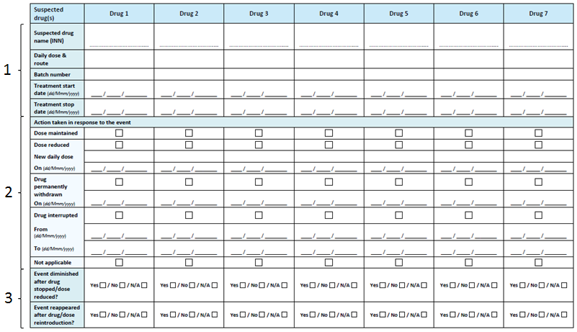
- Up to 7 suspected drugs can be entered, if more suspected drugs have to be reported, the page can be re-printed with the mention ‘Supplemental page’ and incremented numbering ‘Drug 8, 9, 10, etc.’ added manually. Information on each drug including the International Non-proprietary Name (INN - preferred) (or trade name/active substance), daily dose, route of administration, batch number and administration dates should be mentioned.
  - The numbering (Drug 1, Drug 2, Drug 3, etc.) allows for causality assessment in section 3.5.
  - As a convention, in a CT, at least all study drugs (including Standard of Care drugs) are to be considered suspected drugs. In the post-marketing setting, medical judgment should apply when selecting suspected drugs. As a general rule, in a tuberculosis (TB) program, at least all ongoing TB treatments administered at time of event should be suspected. Other ‘non-suspected’ drugs can be recorded as concomitant medications (see section 3.8) or as past drugs (see section 3.9).
  - In case of drug-drug interaction (DDI), all interacting drugs have to be recorded as suspected and the potential/proven DDI mentioned in the Event description section of the SAE Report Form (see section 3.6).
- Action taken following the occurrence of the SAE(s) should be documented for each drug using the possibilities presented in the table. Action taken is considered not applicable, if the drug was already stopped at time of event’s first occurrence or, for example, if the event appeared pre-treatment in a patient enrolled in a CT.
- Information on the appearance/disappearance of the symptoms following changes in drug administration (discontinuation, dose reduction, drug reintroduction, full dose reintroduction) should be documented using the tick boxes.

Causality assessment
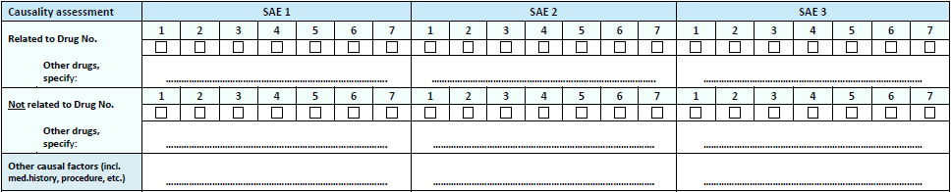
The reporter (the Investigator or co-Investigator in CTs) should determine for each SAE the causal relationship with each suspected drug using the categories defined as follows:
- Related: there is a reasonable possibility that the SAE may be related to the drug(s). Elements in favour of a reasonable causal relationship include (but are not limited to):
- A favourable temporal relationship,
- A positive dechallenge, meaning symptoms are receding when the drug(s) is withdrawn or the dose is reduced,
- A positive rechallenge, meaning symptoms are reappearing when the drug(s) is reintroduced or the full dose is re-administered,
- A plausible pharmacological/biological mechanism of action (whether proven or potential),
- Previous knowledge of similar reaction with the drug(s), or
- No other evident cause (e.g. previous disease, other drugs).
- Not Related: there is no reasonable possibility that the SAE is related to the drug(s). This implies that there is a plausible alternative cause for the SAE that better explains the occurrence of the SAE or that highly confounds the causal relationship between the drug(s) and the SAE.
In the situations where there is insufficient information to evaluate the causal relationship, ‘related’ should be conservatively selected by default.
Any other causal factor including pre-existing conditions, risk factors, trial procedure, etc., should be mentioned as ‘free-text’.

Event description
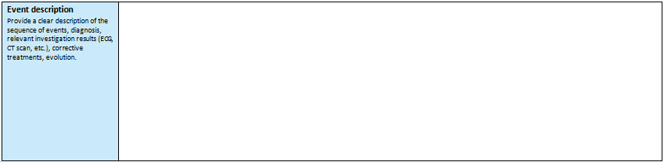
This free-text field allows for a detailed description of the relevant information on the course/sequence of events, relevant investigation results (e.g. ECG, CT scan), drugs or other therapy for the event, hospitalization dates in case of multiple admissions, description of disabilities or sequelae as a consequence of the event, and any other relevant information on the case. Internationally accepted abbreviations can be used when necessary.

Relevant laboratory tests
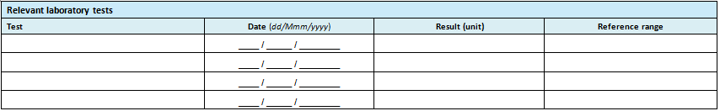
Relevant tests should be listed including test name (e.g. serum blood urea nitrogen), test date, results including units and reference range. Full lab results can be appended to the Report Form if relevant to the case (section 3.11).

Concomitant medications
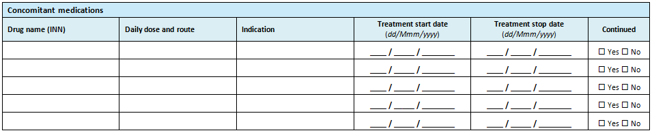
This section aims at capturing all relevant concomitant drugs, including herbals/complements or self-medications. Suspected drugs should be exclusively entered in the dedicated field (see section 3.4), drugs used to treat the event should be entered in Event description (see section 3.6), and past drugs, i.e. those stopped before the start of the TB treatment and other suspected drugs, in the medical history field (see section 3.9).

Medical history
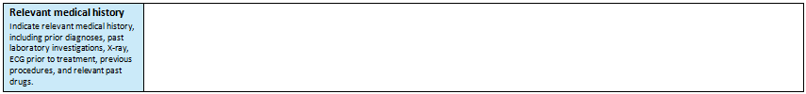
Relevant medical history should include a list of selected prior medical diagnoses, risk factors, prior lab or investigation results (e.g. abnormal sinus rhythm 6 months prior to TB drug start), relevant familial history (e.g. family history of cancer), social circumstances (e.g. ongoing divorce, leaving in a slum area), habits (e.g. alcohol use, drug abuse), past drugs, and any other relevant information to the case. Internationally accepted abbreviations can be used when necessary.

Reporter information
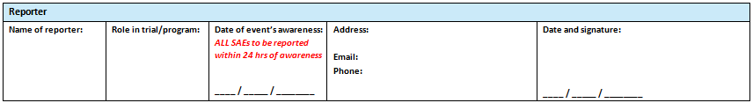
Titles in this section are self-explanatory. The SAE awareness date is crucial for proper expedited reporting to the relevant stakeholders (e.g. Health Authorities), if appropriate. For CTs, the Investigator or co-Investigator is responsible to approve and sign the SAE Report Form. In post-marketing programs, the relevant function (physician, nurse, etc.) should sign the form as per program’s PV guideline.

Case status and annexes
The reporter is expected to pro-actively inform on the possibility of getting additional information on the case. If this information is not known at time of reporting, this field can be left blank.
Any annex to the SAE Report Form such as anonymised discharge summary, lab results, or autopsy reports, should be listed to ensure proper receipt check at MSF PV Unit.

Special situation – Parent/Child Foetus reports
In the situations where a female patient exposed in the frame of CT or a program is found to be pregnant, a Pregnancy Report Form should be populated and transmitted to MSF PV Unit. This is also the applicable process for a pregnancy in the female partner of a male patient exposed in the frame of a CT/program.
In addition, any SAE occurring in the mother or the foetus/child has to be recorded and transmitted to MSF PV Unit using an SAE Report Form.
- In the event of an SAE in the mother (e.g. late miscarriage), the SAE Report Form should mention the mother as the patient (section 3.2) and the serious mother’s event (e.g. late miscarriage) as the SAE (section 3.3). In addition, a Pregnancy Report Form captures all pregnancy information (see Pregnancy Report Form completion guidelines).
- In the event of an SAE in the foetus/child (e.g. spina bifida), the SAE Report Form should mention the foetus/child as the patient (section 3.2) and the serious foetus/child event (e.g. spina bifida) as the SAE (section 3.3). In addition, a Pregnancy Report Form captures all pregnancy information (see Pregnancy Report Form completion guidelines).
- If both the mother and the foetus/child experienced SAEs (e.g. vaginal haemorrhage and foetal distress), 2 SAE Report Forms should be completed (1 for vaginal haemorrhage in the mother and 1 for foetal distress in the baby), as well as 1 Pregnancy Report Form that captures all pregnancy information.

References
ICH E2A - Clinical Safety Data Management: Definitions and Standards for Expedited Reporting. 27 October 1994.
ICH E2B(R2) - Clinical Safety Data Management: Data Elements for Transmission of Individual Case Safety Reports. 5 February 2001.

