

PREGNANCY REPORT FORM

Guidelines for completion

Authors | MSF PV unit
Date | 15-Dec-2015
Version | 2.0

Table of content
Table of content 2
List of abbreviations 3
1. Introduction 4
2 General instructions 4
3 Detailed instructions 5
3.1. Administrative information 5
3.2. Patient information (mother) 5
3.3. Relevant drug(s) exposure before/during pregnancy 5
3.4. Pregnancy information 6
3.5. Infant(s) information 7
3.6. Relevant medical history 7
3.7. Reporter information 7
4 Focuses 7
4.1 When to create foetus/child cases? 7
4.2 What should be done for drug exposure via father? 8
5 References 9

List of abbreviations
CT | Clinical trial
INN | International Non-proprietary Name
PV | Pharmacovigilance
SAE | Serious adverse event
TB | Tuberculosis

Introduction
Pregnancies occurring in clinical trials (CTs) or programs sponsored by MSF are collected and reported using a dedicated form. Unless described otherwise in the CT protocol or the program’s PV guideline, pregnancies with or without serious outcomes are reportable within 24 hours of awareness to MSF Pharmacovigilance (PV) Unit using a Pregnancy Report Form:
Email: PVunit.GVA@geneva.msf.org
Additional information on already transmitted pregnancies, called follow-up information, should be reported similarly within 24 hours of awareness of the new information.
When applicable, Serious Adverse Event (SAE) Report Forms are additionally required to capture information on SAEs occurring in the course of the pregnancy in the mother and/or the foetus/child.

General instructions
The Pregnancy Report Form is designed to specifically follow mothers and foetuses/children exposed to drugs in the frame of CTs or programs. The available fields must be completed as much as possible with the relevant information available at the time of reporting.
The minimal information to be reported includes:
- Name or any identifier of a reporter (e.g. a function such as ‘nurse’ is acceptable),
- Any identifier of the pregnant patient (e.g. patient number, initials, date of birth),
- Exposure during/before pregnancy to at least one drug (study drug in a CT/ delivered drug in a program).
The following general points aim at helping the completion of the Pregnancy Report Form:
- Dates should be provided in the “Day/Month/Year” format: dd/Mmm/yyyy (e.g. 06/Apr/2015). If the exact date is not known, a partial date can be provided and the full date completed later upon follow-up (e.g. UNK/Apr/2015).
- In case you need to add more information than a field allows you to enter, please reprint the page, add manually the mention ‘Supplemental page’, and capture the additional information.
- Upon receipt of follow-up information on a pregnancy already notified (e.g. pregnancy outcome is known), the initial information does not need to be fully repeated on the Pregnancy Report Form, only the new information with identifiers allowing to retrieve the initial information (site number, patient’s identifiers, case number, etc.).
- In case corrections are needed, the correct vs. the incorrect information should be clearly identifiable and the correction should include the initials of the person who performed the modification and the date of such modification.
- All information about the patient must be anonymized in all documents before transmission to the MSF PV Unit.
- One Pregnancy Report Form should be populated for each separated pregnancy of a same patient. Multiple pregnancies should generally be captured within a same Pregnancy Report Form.
The MSF PV Unit is available for questions and further guidance on the Pregnancy Report Form completion.

Detailed instructions

Administrative information
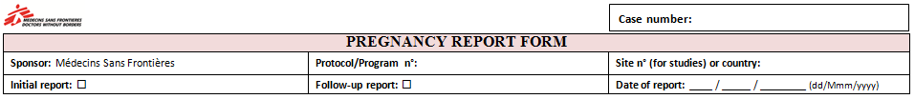
For CTs, protocol and site numbers should be informed. For other programs, the program number or name as well as the country of occurrence of the event should be entered.
When transmitting information on a pregnancy for the first time, the box ‘initial report’ should be ticked, when reporting supplementary information on a pregnancy previously transmitted, ‘follow-up report’ should be selected.
‘Date of report’ field’s title is self-explanatory.
The field ‘Case number’ is available to capture the number of the case attributed by MSF PV unit; at time of initial reporting this field should be left blank.

Patient information (mother)
In Pregnancy Report Forms, the patient is always the mother. For CTs and programs where patients are allocated an alpha-numeric identifier, the appropriate field (‘Patient n°’) should be populated with this information. In the cases, where the patient is the female partner of an enrolled male patient (drug exposure via father), the father’s patient n° should be entered for reference. By using the tick boxes ‘father’ / ‘mother’, there is no ambiguity on who is referred to via the patient number.
All information about the parents must be anonymized. Other fields’ titles are self-explanatory.

Relevant drug(s) exposure before/during pregnancy
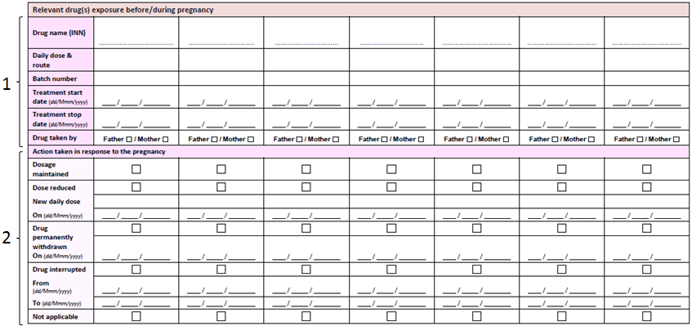
- Up to 7 drugs can be entered, if more drugs have to be reported, the page can be re-printed with the mention ‘Supplemental page’ added manually. Information on each drug including the International Non-proprietary Name (INN - preferred) (or trade name/active substance), daily dose, route of administration, batch number and administration dates should be mentioned. Tick boxes allow identification of whether the mother or the father was taking the drug(s).
  - As a convention, in a CT, all study drugs (including Standard of Care drugs) are to be considered relevant drug exposures. In the post-marketing setting, medical judgment should apply when selecting relevant drug exposure. As a general rule, in a tuberculosis (TB) program, at least all ongoing TB treatments administered at time of event should be considered relevant drug exposures. Other drugs can be recorded as relevant drug exposure as per best medical judgment (e.g. highly active antiretroviral therapy).
  - In the cases, where the patient is the female partner of an enrolled male patient (drug exposure via father), the father’s relevant drugs should be entered. Any relevant pregnancy exposure to a drug taken by the mother should be additionally entered (see also section 4.2). Tick boxes allow identification of whether the mother or the father was taking the drug(s).
  - In the special situation where the pregnancy itself is considered a drug adverse reaction, e.g. if one of the drug is considered to have interacted in any way with the contraception method used, this information should be specifically highlighted and all drugs including contraceptives should be listed.
- Action taken following pregnancy knowledge should be documented for each drug using the possibilities presented in the table. Action taken is considered not applicable, if the drug was already stopped before pregnancy or taken by the father (drug exposure via father).

Pregnancy information
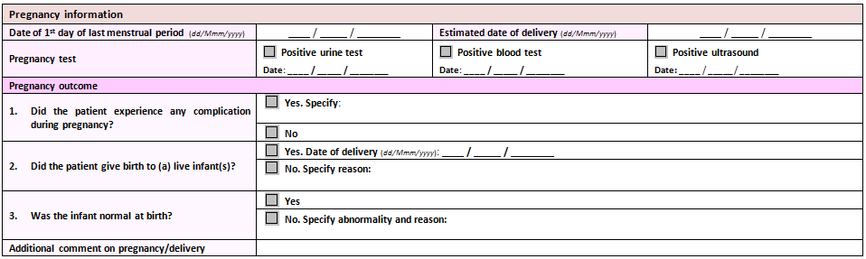
General information on the pregnancy should be collected including the last menstrual period date and the estimated date of delivery (for ongoing pregnancies). The positive pregnancy tests undertaken to confirm pregnancy as well as the corresponding dates should be entered.
Pregnancy outcome information should be captured as follows:
- Pregnancy complications should be described as free text,
- Pregnancy outcome should be detailed:
  - Live birth should be captured as well as date of delivery.
  - In case of detrimental pregnancy outcomes, details on the type of outcome (e.g. miscarriage, foetal death in utero) and underlying causes (when known) should be provided as free text. Elective abortion should also be captured in this field, highlighting the reason for such procedure (e.g. patient’s choice, foetal defects).
    - In case of foetal defects/congenital anomalies, the reporter is expected to create an SAE Report Form to capture detailed information on the foetal abnormality (see also section 4.1).
  - For ongoing pregnancies, when last menstrual period and/or estimated delivery date is unknown, it is advised to mention the pregnancy is ongoing in the field Additional comment on the course of pregnancy.
- Any abnormality in the infant should be briefly described; in parallel the reporter is expected to create an SAE Report Form to capture detailed information on the infant’s abnormality (see also section 4.1).
Additional comments on the course of the pregnancy and/or delivery can be entered as free text.

Infant(s) information
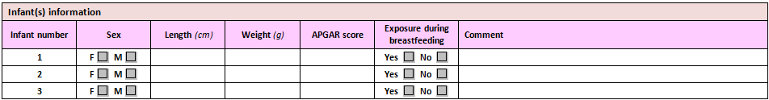
This section aims at capturing detailed information on the live infant(s). For multiple pregnancies, the order of the babies at birth should be followed when filling in the table. Fields’ titles are self-explanatory; a free text field is available for any additional comment on the infant’s health.

Relevant medical history
Relevant medical history of the mother should be included, especially gravidity, parity and abortus, as well as relevant gynaecological diseases.

Reporter information
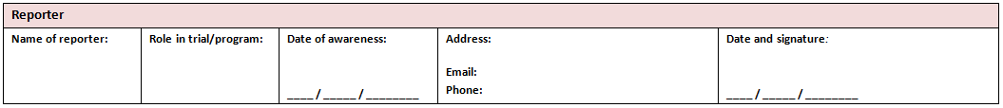
Titles in this section are self-explanatory. For CTs, the Investigator or co-Investigator is responsible to approve and sign the Pregnancy Report Form. In post-marketing programs, the relevant function (physician, nurse, etc.) should sign the form as per program’s PV guideline.

Focuses

When to create foetus/child cases?
In the situations where a female patient exposed in the frame of CT or a program is found to be pregnant, a Pregnancy Report Form should be populated and transmitted to MSF PV Unit. This is also the process for a pregnancy in the female partner of a male patient exposed in the frame of a CT/program.
In addition, any SAE occurring in the mother or the foetus/child has to be recorded and transmitted to MSF PV Unit using an SAE Report Form.
- In the event of an SAE in the mother (e.g. late miscarriage), an SAE Report Form should record the serious mother’s event with the patient being the mother. In addition, the Pregnancy Report Form should capture all pregnancy information.
- In the event of an SAE in the foetus/child (e.g. spina bifida), an SAE Report Form should record the serious child’s event with the patient being the child. In addition, the Pregnancy Report Form captures all pregnancy information.
- If both the mother and the foetus/child experienced SAEs (e.g. vaginal haemorrhage and foetal distress), 2 SAE Report Forms should be completed (1 for vaginal haemorrhage in the mother and 1 for foetal distress in the baby), as well as 1 Pregnancy Report Form that captures all pregnancy information.

What should be done for drug exposure via father?
In the cases, where a pregnancy occurs in the female partner of an enrolled male patient (i.e. the father is treated in the frame of the MSF-sponsored CT or MSF program and not the mother):
- All patient information (age, date of birth, height and weight) should be entered for the mother. Only the father’s patient n° should be entered for reference (ticking the box “father”).
  - Example, the wife of the male patient n°002 enrolled in the TEST program is found pregnant. Her name is MM, she is born in 1976 and her height is 165 cm / weight 50 kg.
- Relevant drugs taken by the father should be entered and identified using the tick box “father”. Any relevant exposure to a drug taken by the mother should be entered and identified using the tick box “mother”.
  - Example, the male patient n°002 was treated with interferon in the frame of the TEST Program, this drug is entered as relevant pregnancy exposure. In addition, his wife (MM) was receiving efavirenz during pregnancy.
All other fields should be completed as guided in sections 3.4 to 3.7. The mother’s information must be treated in a confidential way with the same precautions as the father’s information. Signature of an Informed Consent should be considered for the mother, as applicable.
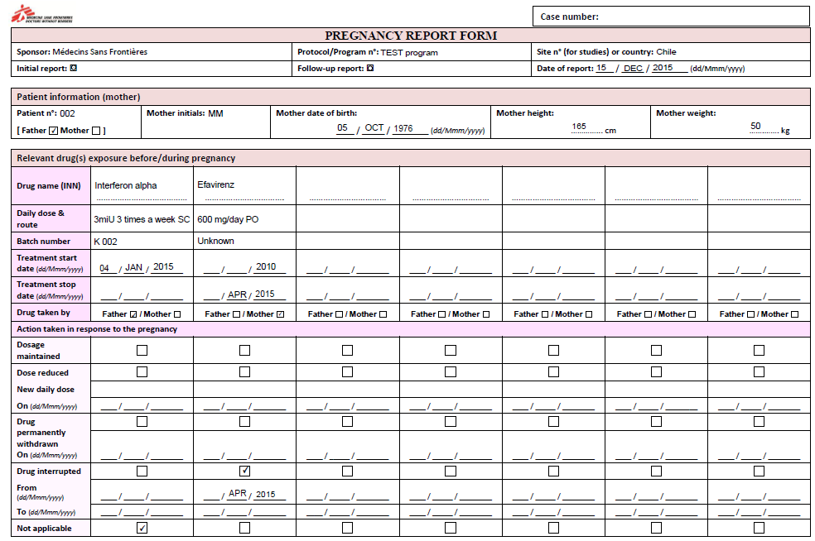

References
ICH E2A - Clinical Safety Data Management: Definitions and Standards for Expedited Reporting. 27 October 1994.
ICH E2B(R2) - Clinical Safety Data Management: Data Elements for Transmission of Individual Case Safety Reports. 5 February 2001.

