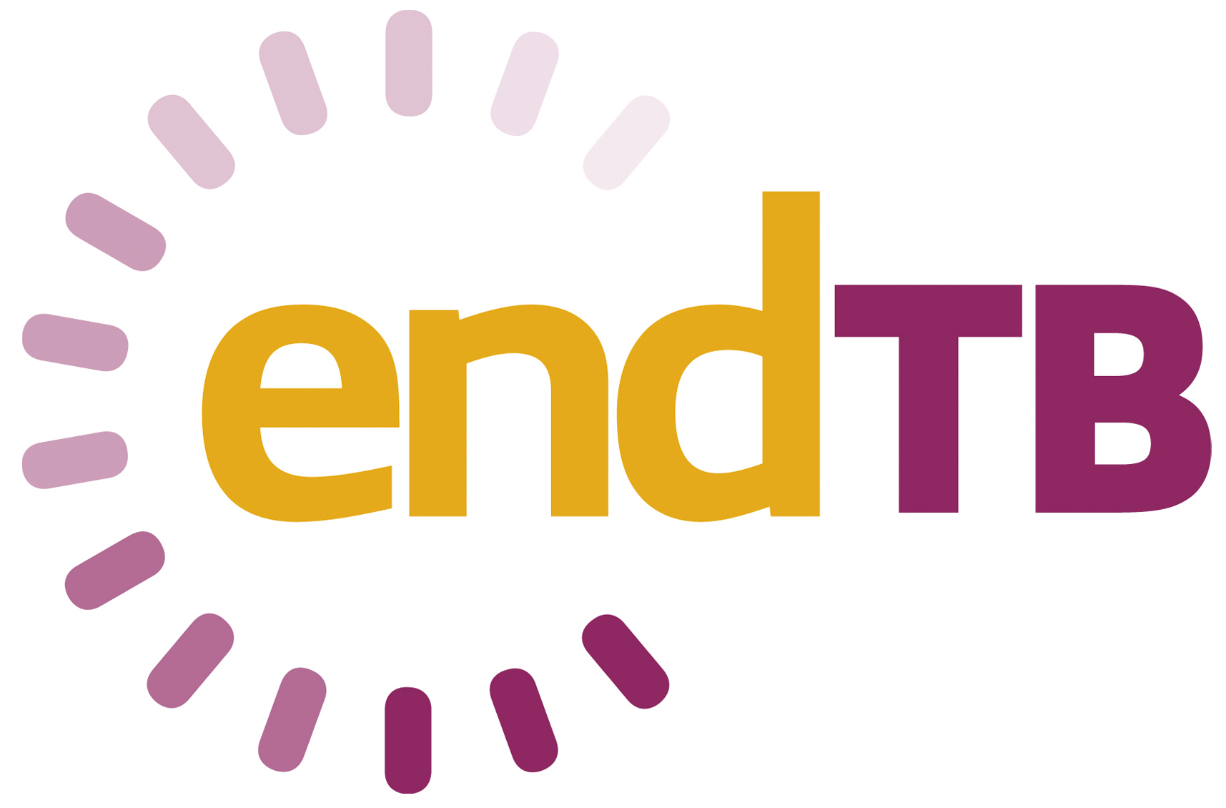

# MedDRA coding in the endTB and endTB-Q clinical trials

# *Working Instruction*

|  |  |
| --- | --- |
| **Date:** | 8-May-2020 |
| **Version:** | 2.0 |
| **Author:** | Nathalie Lachenal, Pharmacovigilance officer |

# Table of Contents

1 Scope and objective 3

2 Responsibilities and timelines 3

3 Quality control and coding consistency 3

4 Coding library archiving 3

5 References 3

6 Revision History 3

# Scope and objective

This working instruction aims at describing the work flow for the coding of medical terms using the Medical Dictionary for Regulatory Activities (MedDRA) dictionary for the endTB and endTB-Q clinical trials. The version of MedDRA in use at the start of the endTB clinical trial is version 19.1; the version in use at the start of the endTB-Q clinical trial is version 22.1. The general guidance from MedDRA (Points to Consider, from version 19.1) is the convention in use in the clinical trials for medical coding.

The clinical database (OpenClinica) fields including terms submitted to medical coding are adverse events.

# Responsibilities and timelines

The coding should be performed the 1st Monday of every month under the responsibility of the Pharmacovigilance Officer and the study central co-investigator.

|  |  |  |
| --- | --- | --- |
| **Timelines** | **Activity** | **Responsible** |
| 1st Monday of the month | Extraction of the data listing to be coded including all new entries for AEs since last coding round | Data Management Team |
| + 1 week | Automatic coding performed using the reference coding library for the clinical trial (see section 3) |
| + 2 week | Terms without a match in the reference coding library are sent by the Central Data Manager to the PV officer for coding | Pharmacovigilance officer |
| Queries sent in case of unclear terms/questions to the Site Study Coordinator for discussion with the responsible investigators |
| + 3 weeks | Term clarification as needed with update of source documents (as appropriate) | Site investigators and Site Study Coordinator |
| Term verbatim change in OpenClinica (if needed) as instructed by the investigators and the Site Study Coordinator and documented in the appropriate source documents | Site Data Manager |
| Validation of the new entries in the coding library | Study Central Co-Investigator |

# Quality control and coding consistency

The Data Management Team is responsible for the creation and maintenance of a coding library for the clinical trial. Meaning every term coded is registered in a dedicated library and will serve as the reference for further coding of the same term.

The Pharmacovigilance Officer codes all terms that have a direct match in the dictionary and suggests coding for the other terms. The Central Co-Investigator validates the new library entries based on the suggestions from the Pharmacovigilance Officer.

# Coding library archiving

The Data Management Team is responsible to archive the coding library as per Epicentre procedures.

# References

* MedDRA Points to Consider versions from 19.1, release 3.12, 01-Sep-2016.
* Data Management Plan.

# Revision History

|  |  |  |  |
| --- | --- | --- | --- |
| **Version** | **Date** | **Description of change** | **Author** |
| 1.0 | 21-Sep-2017 | Initial version | Nathalie Lachenal |
| 2.0 | 08-May-2020 | endTB-Q clinical trial added. The term Data Management Team was used instead of Data Manager. | Nathalie Lachenal |