# Standard Operating Procedures for

**Visual Acuity Screening**

|  |  |
| --- | --- |
| **SOP Number**: SP-003-ET | **Effective Date**: 21-Jan-2019 |
| **Version Number and Date**: 2.1, 12-Dec-2018 | |

**Table of contents**

1. PURPOSE 2

2. SCOPE 2

3. RESPONSIBLE FUNCTIONS 2

4. DEFINITIONS and ABBREVIATIONS 3

5. PROCEDURE: 4

5.1. Materials Needed for Visual Acuity Screening 4

5.2. Preparation 4

5.3. Visual Acuity Screening 4

5.4. Visual Acuity Result Interpretation 5

6. REFERENCES 5

7. SUPPORTING DOCUMENTS 5

8. APPENDIX 5

# Standard Operating Procedure for

# Visual Acuity Screening

## PURPOSE

|  |
| --- |
| This standard operating procedure (SOP) describes the procedures for visual acuity screening in the endTB observational study and clinical trials to detect vision problem in participants. |

## SCOPE

|  |
| --- |
| This SOP is developed for health care and research professionals conducting visual acuity screening among participants of the endTB observational study and clinical trials. |

## RESPONSIBLE FUNCTIONS

|  |  |
| --- | --- |
| **Function** | **Activities** |
| **Clinical staff** | * Prepares visual acuity screening materials and test environment, * Instructs patients on the visual acuity screening procedures, * Conducts visual acuity screening, * Interprets visual acuity screening results, * Reviews patients’ medical history to detect abnormal changes from baseline. |
| **Research staff** | * Prepares visual acuity screening materials and test environment, * Instructs patients on the visual acuity screening procedures, * Conducts visual acuity screening. |

## DEFINITIONS and ABBREVIATIONS

1. 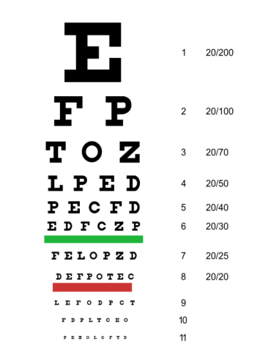**Snellen Chart:** an eye chart with Roman alphabets used to measure visual acuity.
2. 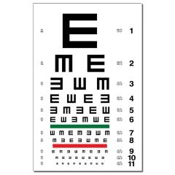**Tumbling E Chart**: an eye chart used to measure visual acuity among patients who are not familiar with the Roman alphabet or illiterate.
3. **Golovin-Sivtsev Chart:** an eye chart with Cyrillic alphabet used to measure visual acuity for literate and illiterate patients.

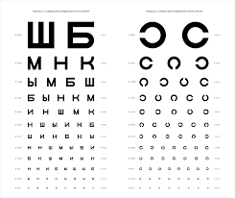

## PROCEDURE:

### 5.1. Materials Needed for Visual Acuity Screening

* 6- meter or 3-meter Snellen chart or Tumbling E Chart, or 5-meter Golovin-Sivtsev table

### 5.2. Preparation

**Clinical and research staff** should locate a work environment with adequate natural light and minimal interruption. A Snellen or Tumbling E Chart should be placed either 20 feet (6 meters) or 10 feet (3 meters) away from the participant, according to the specific chart used. In a smaller room, the chart may be hung behind the participant’s seat, using mirrors to make it appear in front of you at a simulated distance of 20 feet. If a Golovin-Sivtsev table is used, it should be placed 5 meters away from the participant.

**Clinical and research staff** should ask participants to wear their glasses if needed for the test.

### Visual Acuity Screening

**Clinic and research staff** is recommended to follow the procedural details below:

* + 1. Introduce one’s self and verify the subject’s name and date of birth. Subject identifiers must match the clinical chart.
    2. Have the participant seated in the designated work area.
    3. Inform the participant of the purpose and the procedures of visual acuity screening.
    4. Instruct the participant to cover one eye with an eye occluder without pressing it; if an eye occluder is not available, instruct the participant to use his/her palm.
    5. Ask the participant to read aloud the smallest line of letters that he/she can see on the chart
    6. Repeat steps 4 and 5 for the other eye.
    7. Record the test score corresponding to the smallest line that the patient can read on the chart.

### Visual Acuity Result Interpretation

**Clinical staff** will record the visual acuity test score as a fraction:

* The top number refers to the distance participant sat from the chart.
* The bottom number indicates the distance at which a person with normal eyesight could read the same line the patient correctly read.
* If the participant misses 1 or 2 letters on the smallest line that he/she can read, he/she is still considered to have vision equal to that line.
* A 20/20 result with Snellen or Tumbling E, or 1.0 with Golovin-Sivtsev, are considered normal. Results less than 20/20 or 1.0 will be recorded as abnormal vision.

**Clinical staff** should refer to participant’s medical history to check for any changes of vision acuity from baseline.

## REFERENCES

* Liz Segre. Eye testing – the eye chart and 20/20 vision. All About Vision.com 2015. <http://www.allaboutvision.com/eye-test/>
* US National Library of Medicine. Visual Acuity Test. 2013. <http://www.nlm.nih.gov/medlineplus/ency/article/003396.htm>

## SUPPORTING DOCUMENTS

None

## APPENDIX

|  |  |
| --- | --- |
| **Number** | **Title** |
| A1 | **Golovin–Sivtsev Chart Conversion Table** |

**Appendix 1. Golovin–Sivtsev Chart Conversion Table**

|  |  |
| --- | --- |
| **Golovin-Sivtsev**  **(Visus)** | **Visual acuity**  **(%)** |
| 1.0 | 100% |
| 0.9 | 90% |
| 0.8 | 80% |
| 0.7 | 70% |
| 0.6 | 60% |
| 0.5 | 50% |
| 0.4 | 40% |
| 0.3 | 30% |
| 0.2 | 20% |
| 0.1 | 10% |