# Standard Operating Procedures for

**Measuring and Recording Vital Signs**

|  |  |
| --- | --- |
| **SOP Number**: SP-005-ET | **Effective Date**: 01-Jul-2016 |
| **Version Number and Date**: 2.0 , 01-Jul-2016 | |

**Table of contents**

1. PURPOSE 2

2. SCOPE 2

3. RESPONSIBLE FUNCTIONS 2

4. DEFINITIONS and ABBREVIATIONS 2

5. PROCEDURE 2

5.1. Materials Needed for Vital Signs Measurement 2

5.2. Radial Pulse Assessment 3

5.3. Respiratory Rate Assessment 3

5.4. Body Temperature Assessment 4

5.5. Blood Pressure Assessment 5

5.6. Body Weight Assessment 6

5.7. Body Height Assessment 7

6. REFERENCES 8

7. APPENDIX 8

# Standard Operating Procedures for:

# Measuring and Recording Vital Signs

## PURPOSE

|  |
| --- |
| This standard operating procedure (SOP) describes the procedures for assessing and recording participants’ vital signs for the endTB Observational Study and Clinical Trial. |

## SCOPE

|  |
| --- |
| This SOP is developed for health care and research professionals assessing vital signs in participants of the endTB Observational Study and Clinical Trial. Specifically, SOPs for: pulse, respiratory rate (RR), temperature, blood pressure (BP), weight and height are described. |

## RESPONSIBLE FUNCTIONS

|  |  |
| --- | --- |
| **Function** | **Activities** |
| **Clinical staff** | * Conducts vital signs measurement and recording |

## DEFINITIONS and ABBREVIATIONS

**Bpm:** beats per minute; measurement unit for pulse

**RR:** respiratory rate, measured in breaths per minute

**°C**: degrees Celsius; measurement unit for temperature

**mmHg**: millimeters of mercury, measurement unit for systolic maximum and diastolic minimum blood pressure

**Kg**: kilogram; measurement unit for body weight

**Cm**: centimeter; measurement unit for body height

## PROCEDURE:

### 5.1. Materials Needed for Vital Signs Measurement

* Timer with seconds (watch or clock)
* Thermometer (digital, glass, or mercury)
* Gauze pad, tissue, or towel
* Alcohol-based disinfectant to clean the thermometer
* Sphygmomanometer (digital, mercury, or aneroid)
* Stethoscope
* Calibrated weight scale (mechanical or digital)
* Wall mounted height chart or stadiometer

### 5.2. Radial Pulse Assessment

**Clinical staff** is recommended to follow the procedural details below:

1. Introduce one’s self and verify the subject’s name and date of birth. Subject identifiers must match the clinical chart.
2. Allow the subject to sit calmly and then take the pulse.
3. Using the index and middle finger, locate the radial artery on the inside of the wrist toward the thumb, until you feel the beats.
4. Note the time and start counting the number of pulse for 60 seconds beginning at the end of expiration. Count for a full 60 seconds.
5. Record the number of beats per minute (bpm).
6. If it is hard to feel the radial pulse, you can take:
   1. the carotid pulse: located on the neck, below the trachea under the angle of the jaw
   2. the femoral pulse: located at the crease of the groin between the pubic bone and the iliac crest
7. **Normal resting heart rate is: 60 - 100 beats per minute** (≥12 years old).
8. If the pulse is outside the normal range, allow the patient to rest for 30 minutes and take the pulse again, rule out anxiety, high fever and cardiac causes.

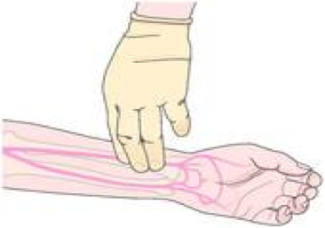

### Respiratory Rate Assessment

**Clinic and staff** is recommended to follow the procedural details below:

1. Note: whenever possible, measure the respiratory rate outside of the subject's awareness, so he/she is unable to influence it.
2. Face the subject so that the subject’s face and excursions of the chest wall can be easily observed. Have the subject remove bulky or loose clothing if necessary.
3. Rather than relying solely on visual assessment of respiratory excursions, it is often easier and more accurate to gently place one hand on the subject’s chest wall and feel the movements of the chest wall in order to count respirations. This method allows one to watch the second hand of the timer and count (by feeling the respiratory excursion) easily at the same time. This method is also very useful in counting respirations of subjects lying in bed. Auscultation of the chest and placement of the stethoscope in front of the mouth is also useful for counting respirations.
4. Note the time and start counting the number of respirations for 60 seconds beginning at the end of expiration. Count for a full 60 seconds.
5. Record breaths per minute result in the form.
6. **Normal respiratory rate in an adult is: 12–20 breaths per minute**.

### Body Temperature Assessment

**Clinic and staff is recommended to follow the procedural details below:**

1. Wash hands or disinfect them with an alcohol-based disinfectant.
2. If using a mercury thermometer, shake the thermometer enough so the mercury can go to the contraction chamber.
3. **Axillary temperature**:
   1. Ask the subject to raise his/her arm so the underarm is fully exposed.
   2. Pat the underarm dry with a gauze pad as excessive moisture can lead to inaccurate readings.
   3. Wedge the bulb of the thermometer securely into the center of the subject’s armpit. Pin subject’s arm against his/her side.
   4. To obtain an accurate reading, leave the thermometer in the subjects’ armpit for 5 to 10 minutes (can use this time to measure pulse and respiratory rate).
   5. Remove the thermometer from the axilla and wipe the thermometer with a gauze pad.
4. **Oral temperature**:
   1. With the subject’s mouth open, place the bulb of the thermometer under the tongue and ask the subject to close the lips around the thermometer and **do not bite the glass/mercury thermometer**.
   2. Keep the thermometer in the mouth for 3 minutes.
   3. Remove the thermometer without touching the tips and record the temperature to at least one decimal in the form.
   4. Wipe the thermometer with a tissue.
5. Hold the thermometer at eye level, parallel to the floor, and record the temperature to at least one decimal place in the form.
6. Disinfect the thermometer in an alcohol-based disinfectant.
7. **Readings**:
   1. Normal: 35.0 °C - 37.5 °C (95.0 °F - 99.5 °F)
   2. Hypothermia: <35.0 °C (<95.0°F)
   3. Hyperthermia: >37.5 °C (>99.5°F )
8. Note: axillary temperature tends to be 0.3 to 0.4 degrees lower than the oral temperature.

### Blood Pressure Assessment

**Clinic and staff** is recommended to follow the procedural details below:

1. Note: DO NOT measure blood pressure:
   1. in a paralyzed arm
   2. on a burn or wound
   3. on an arm with an IV infusion
2. BP should be recorded with the subject at rest: seated or in supine position if subject cannot sit.
3. BP is measured on the LEFT ARM where the pressure is slightly higher.
4. Measure the BP in both arms when specifically ordered by the physician.
5. Place subject’s left arm on the table, slightly flexed and palm facing upwards.
6. Outer clothing such as jacket or sweater should be removed and sleeves should be rolled up to the shoulder making sure that two fingers can be placed under the sleeve without difficulty.
7. Wrap the sphygmomanometer cuff around the subject's arm and adjust it so that it is neither too loose nor too tight: there should be room to slide the stethoscope between the skin and the cuff.
8. The lower edge of the cuff should be about 2 cm above the crease of the elbow.
9. For an aneroid sphygmomanometer, adjust the sphygmomanometer needle to zero.
10. Place the stethoscope in the bend of the elbow, at the brachial artery.
11. Close the screw and inflate the cuff to 180 mmHg and check that the radial pulse disappears; if not, inflate at increments of 10 mmHg until the radial pulse disappears.
12. Slowly deflate the cuff at 3 mmHg per second by loosening the screw:
    1. When the first sound of radial pulse is heard, check the sphygmomanometer reading - this corresponds to the first number of BP (Systolic pressure)
    2. When the last sound of radial pulse is heard, check the sphygmomanometer reading - this corresponds to the second number of BP (Diastolic pressure)
13. Record the systolic and diastolic measurements in millimeters of mercury (mmHg): S / D mmHg.
14. Clean the sphygmomanometer and stethoscope daily with a disinfectant.
15. Joint National Committee (JNC) 8 Classification of Normal BP:

|  |  |  |
| --- | --- | --- |
| **Subject subgroup** | **Target SBP (mmHg)** | **Target DBP (mmHg)** |
| ≥ 60 years old | < 150 | < 90 |
| < 60 years old | < 140 | < 90 |
| > 18 years old with diabetes | < 140 | < 90 |
| >18 years old with chronic kidney disease | < 140 | < 90 |

### Body Weight Assessment

**Clinic and staff** is recommended to follow the procedural details below:

1. Ask the subject to remove shoes, long trousers, coats and sweaters; only light, indoor clothing should be worn. If cultural constraints hinder removal of heavy clothing, adjustments should be made before recording the final weight measurements.
2. Ask the subject to stand in the center of the measuring scale, hands at sides and looking straight ahead.
3. After the subject is correctly positioned and the measurement device is stable, record the weight reading in kilograms (kg) to at least one decimal place in the form.
4. Note: if using a mechanical scale, be sure to read the measurement with the line of sight directly in front of the value rather than at an angle or from even slightly off to the side.
5. Clean the weight scale daily with a disinfectant.

### Body Height Assessment

**Clinic and staff** is recommended to follow the procedural details below:

1. Ask the subject to take off his/her shoes and remove any hair ornaments, hat, buns, braids, etc. from the top of the head.
2. Ask the subject to stand with back against the backboard with body weight evenly distributed, both feet flat on the platform, both heels together and toes apart.
3. The subject’s head, shoulder blades, buttock and heels should make contact with the backboard.

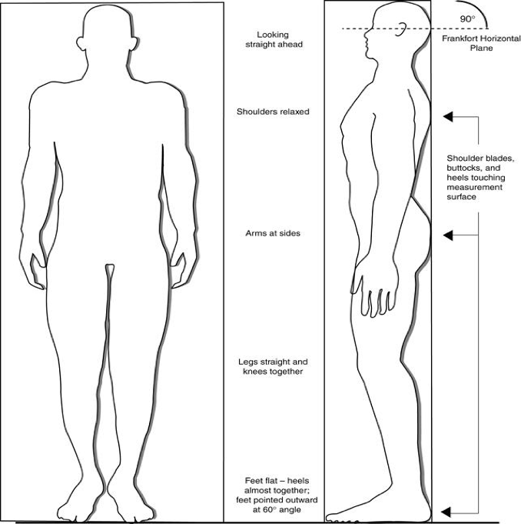

1. If the subject is not able to stand up straight, ask the subject to position vertically so that only the buttocks and the heels, or buttocks and the head are in contact with the backboard.
2. Ask the subject to inhale deeply, look straight ahead and maintain a fully erect posture.
3. Record the height measurement in centimeters (cm) in the form.
4. Clean the height chart/stadiometer daily with a disinfectant.

## REFERENCES

* ANRS 12292 Rifavirenz Study SOP 28 Pulse, SOP 29 Temperature, SOP 30 Weight and Height, and SOP 31 Respiratory Rate
* Joint National Committee (JNC) 8 Classification

## APPENDIX

None