**Appendix 1. Algorithm Trees for Treatment Outcomes Assignment**

Each outcome of the two Steps is followed by a **number** between brackets, representing the number of the corresponding outcome as listed in endTB/Q Case Report Form 15.

1. **Outcome assignment at Week 39**

**Step 1:**

If any of the following is present, the outcome is classified as ***unfavorable***:

* + - Replacement or addition of ≥1 drugs in the experimental arm for endTB and endTB-Q or in the control arm if using the shortened regimen for endTB **(3)**
    - Replacement or addition of ≥2 drugs in the control arm for endTB-Q and for endTB **(2)**
    - Death **(4)**

**Step 2:**

If none of the above is present, follow the flow chart below:

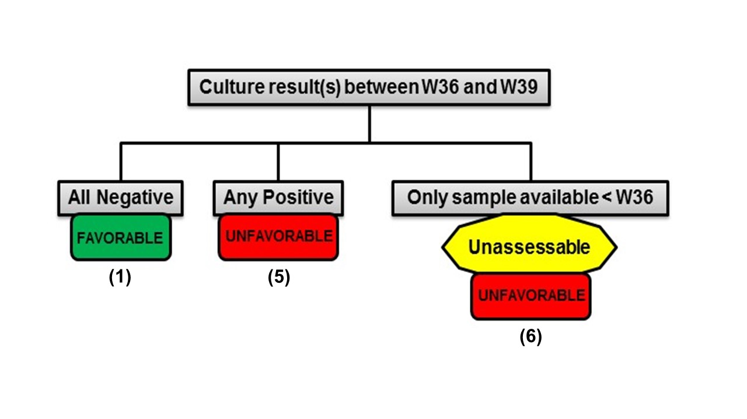

1. **Outcome assignment at Week 73**

**Step 1:**

If one of the following is present, the outcome is classified as ***unfavorable***:

* + - Replacement or addition of ≥1 drugs in the experimental arm for endTB and endTB-Q or in the control arm if using the shortened regimen for endTB **(4)**
    - Replacement or addition of ≥2 drugs in the control arm for endTB-Q and for endTB **(5)**
    - Initiation of a new MDR-TB regimen **(6)**
    - Death **(7)**
    - The outcome at Week 39 was classified as unfavorable for any reason other than unassessable **(12)**
    - Loss to follow-up (this only applies to participants whose scheduled follow up ends at Week 73)

**Step 2:**

If none of the above is present, follow the flow chart below:

1. **Outcome assignment at week 104**

**Step 1:**

If one of the following is present, the outcome is classified as ***unfavorable***:

* + - Replacement or addition of ≥1 drugs in the experimental arm for endTB and endTB-Q or in the control arm if using the shortened regimen for endTB **(4)**
    - Replacement or addition of ≥2 drugs in the control arm for endTB-Q and for endTB **(5)**
    - Initiation of a new MDR-TB regimen **(6)**
    - Death **(7)**
    - The outcome at Week 73 was classified as unfavorable for any reason other than unassessable **(12)**
    - Loss to follow-up **(13)**

**Step 2:**

If none of the above is present, follow the flow chart below:

