Appendix 1. Diagnostic and therapeutic Hepatitis C virus infection algorithm

1. If HCV genotype available:
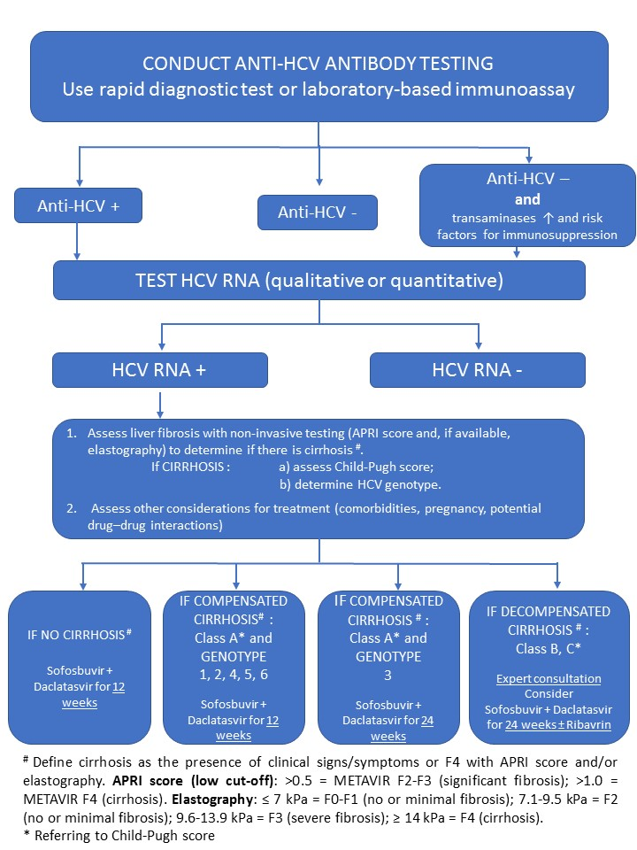

2. If HCV genotype is not available/not done and HCV genotype 3 prevalence < 5%:
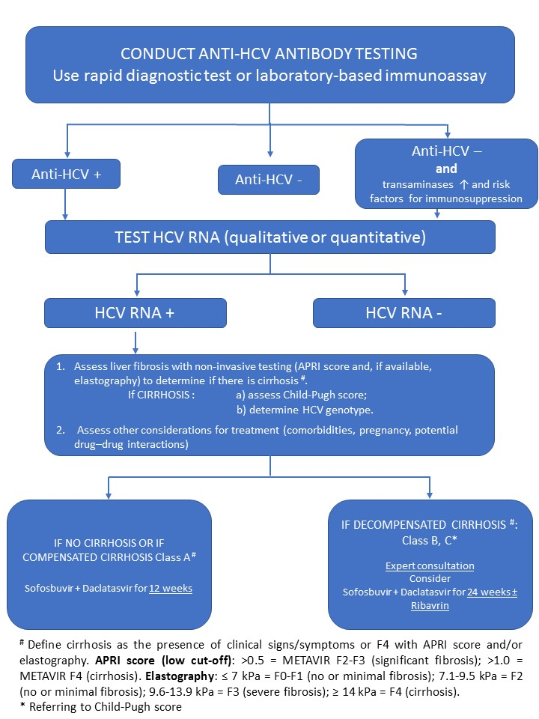

3. If genotype not available and HCV genotype prevalence ≥ 5%, or HCV genotype prevalence unknown:

